**E-Flight starts with electric flying in the Caribbean**

**Dutch startup E-Flight launched last year the first electric flight academy of Europe in the Netherlands at Teuge Airport. In May this year, E-Flight will open its first electric flight academy in Bonaire. E-Flight sees endless possibilities and cooperations in terms of innovation and sustainability within the Caribbean. The short distances between the islands, the sustainable objectives, and the benevolence of local parties make this area the perfect playground for a huge acceleration of electric flying.**

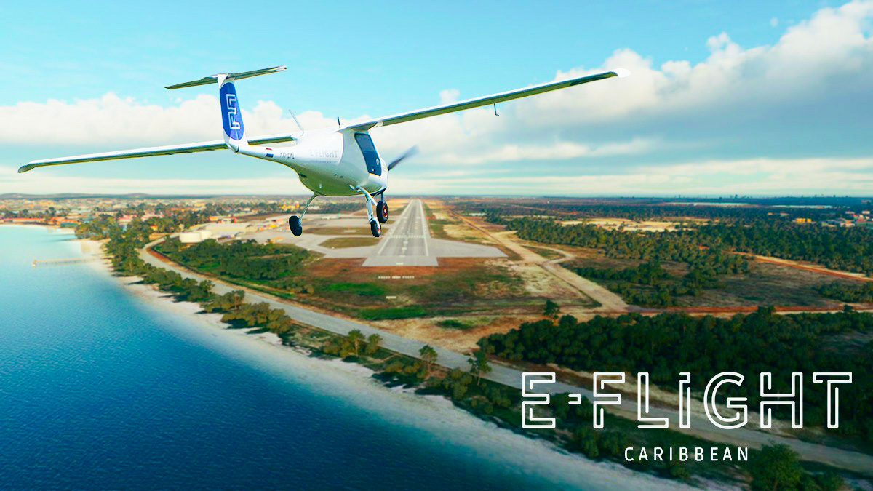

**Sustainable at the highest level**

E-Flight Caribbean will aim for a broad target audience in a wide geographical area. The sustainable flight academy will attract students from the ABC-islands itself or Dutch students who want to do their flight training (partly) abroad. And also students from South America, and the south coast of the USA. At this moment flight academies in this region are operating mainly as American FAA training institutes. While E-Flight operates according to European EASA regulations. All around the world, there's an increase of countries and operators who operate according to the EASA regulations because this represents the highest level.

**Scalable with Airplanes As a Service (AAS)**

E-Flight sees the Caribbean area as a huge emerging market for electric flying. The weather conditions are excellent for flight training and electric flying fits perfectly the sustainable objectives of the ABC islands. E-Flight already encountered a lot of demand for electric flying in the Netherlands. Within one year they grew from 0 till 30 students and they performed more than 2000 electric take-offs. To be prepared for rapid growth in the Caribbean, E-Flight started a close collaboration with French lease company

[Green Aerolease](https://aerolease.green/)

. Green Aerolease has a fleet of 50 electric planes of the Pipistrel Velis Electro type, which they offer as Airplanes As a Service (AAS) to flight academies with sustainable ambitions.

**Sustainable aviation maintenance by European regulations**

Because of E-Flight operates fully by the European EASA standards, they will need EASA certified maintenance. Therefore E-Flight will cooperate with Dutch maintenance company

[Hangar One](https://www.hangar-one.eu/)

. Right now they are in the development phase of strategy and planning to expand in the Caribbean.

----

**About E-Flight**

E-Flight believes in clean and quiet airspace where everybody wants to fly and can keep flying, without guilt. By making as many people as possible enthusiastic about electric flying, E-Flight plays an accelerating role in making aviation on a global scale more sustainable.

[www.eflight.nl](http://www.eflight.nl)

- contact: Merlijn van Vliet -

[merlijn@eflight.nl](mailto:merlijn@eflight.nl)

- +31 6 15 89 65 06

**About Green Aerolease**

Green Aerolease is a subsidiary of the W3 group which organizes the provision of decarbonized light aircraft by proposing a « ready for use » rental service to aeronautical operators (aeroclubs, piloting schools, airlines,…). The company is aiming to accelerate the ecological transition of light aviation in France and in Europe by proposing a new renting offer, unprecedented in the electric aviation world.

[www.aerolease.green](http://www.aerolease.green)

- contact: Guillaume Abéguilé -

[guillaume.abeguile@w3.bzh](mailto:guillaume.abeguile@w3.bzh)

- +33 6 72 60 01 39

**About Hangar One**

Hangar One relies on decades of experience of its employees and it maintains a worldwide network in the aviation industry. All our engineers hold an EASA and/or FAA aircraft maintenance license. Combined our mechanics have over 150 years of experience in aircraft maintenance on types both large and small.

[www.hangar-one.eu](http://www.hangar-one.eu/)

- contact: Yufang Guo - voorzitter en CEO van Hangar One

**Over: E-Flight Academy**

E-Flight gelooft in een wereld met een stil en schoon luchtruim waarin iedereen wil en kan blijven vliegen zonder schuldgevoel. Door zoveel mogelijk mensen enthousiast te maken voor elektrisch vliegen, hoopt E-Flight een versnellende rol te spelen in de verduurzaming van de luchtvaart op mondiale schaal.

**Newsroom**

View the full press release including more photos and videos in our Newsroom.

[View the full press release](https://e-flight-academy.presscloud.ai/press/e-flight-starts-with-electric-flying-in-the-caribbean)

[View all previous press releases](https://e-flight-academy.presscloud.ai)

**Contact information**

Name: Merlijn van Vliet

Function: Marketing & PR

Email: merlijn@eflight.nl

Phone: 0615896506